**Design Photo Journal - “The Tortoise and the Hare”**

Team members: Zichang Liu, Venus Sun, Longkun Yang, Wushuang Zhou

**Initial Design:**

After playing the game “Up the River” during class, we decided that we wanted to make a game that has a certain path and the players have to “race” to the end to win while rolling dice to move, just like Monopoly, or Aeroplane Chess. Before deciding on a certain theme for the game, we first started to brainstorm about what interesting features we could bring to the game to create a new playing experience. Venus brought up the story of The Tortoise and the Hare, saying that maybe we could have characters that move at different paces and we could utilize the rule somehow to allow speed exchanges between the players so that we could add some uncertainty to the game. We decided to use this background story to build our game, and after discussion we decided that it would be too complicated and a bit unfair to allow speed exchanges, we would rather design a rule that would allow position exchanges to make it more fun. After making decisions on the basis of the game, we decided to first design some rules individually and schedule a second meeting to finalize a version ready for play tests. Wushuang took the responsibilities of making original art designs for the characters as well as the map. 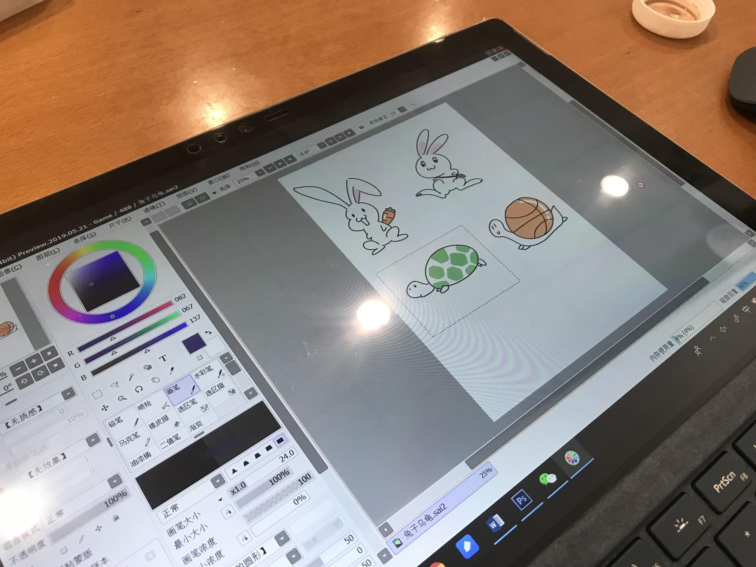

**Making of the alpha version:**

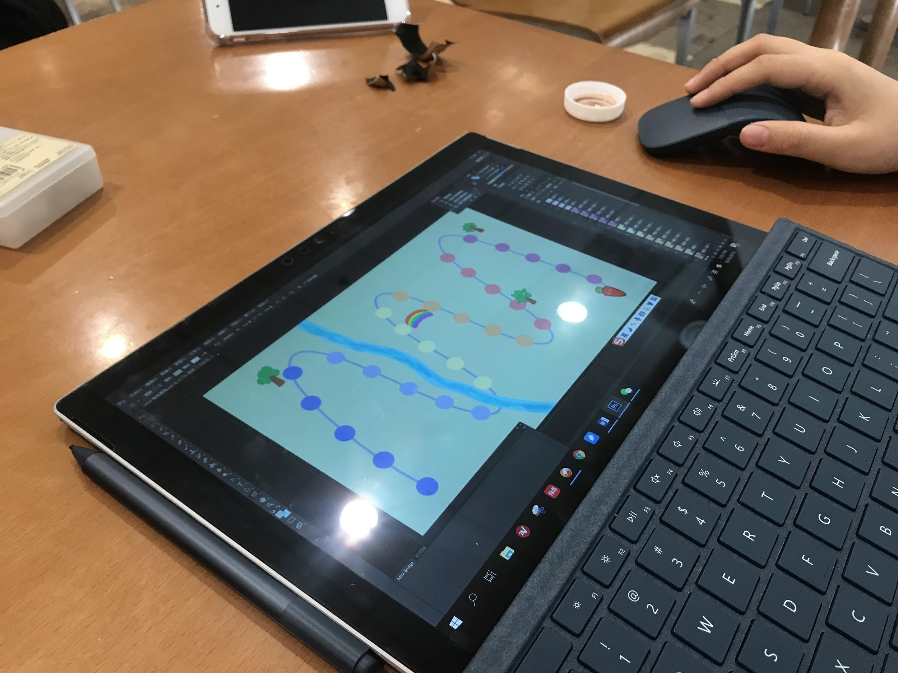

During the second meeting, we finalized a few rules for a playable alpha version of our game. We decided that we would have 30 spots for the whole map, and we will use a 8-sided-dice to determine the steps for the characters. Each player will have one tortoise and one rabbit to play with. We set the speed for the characters so that the tortoise would move at a speed half of the speed of the rabbit, and we would reserve the number 8 not for movement, but for exchanging positions of the characters. In order to make things fair, we decided to only let the player exchange positions of the same type between opponents, while they can exchange freely between the two characters of their own. As for some “special points” on the map to increase the fun, Zichang brought up a few really interesting ideas, one is to include a river whereas the rabbit cannot cross until the tortoise of its own team has crossed, and another one is to include a fast slide from one point to another as a “power-up”. We adopted those two ideas and also added a few more “stopping points” for the rabbit so that we have a relatively similar moving rate for the rabbit and the tortoise overall. Wushuang brought the designs she had made for the characters and also drew the whole map as we discussed about the details in the game.

**Playtests and revisions:**

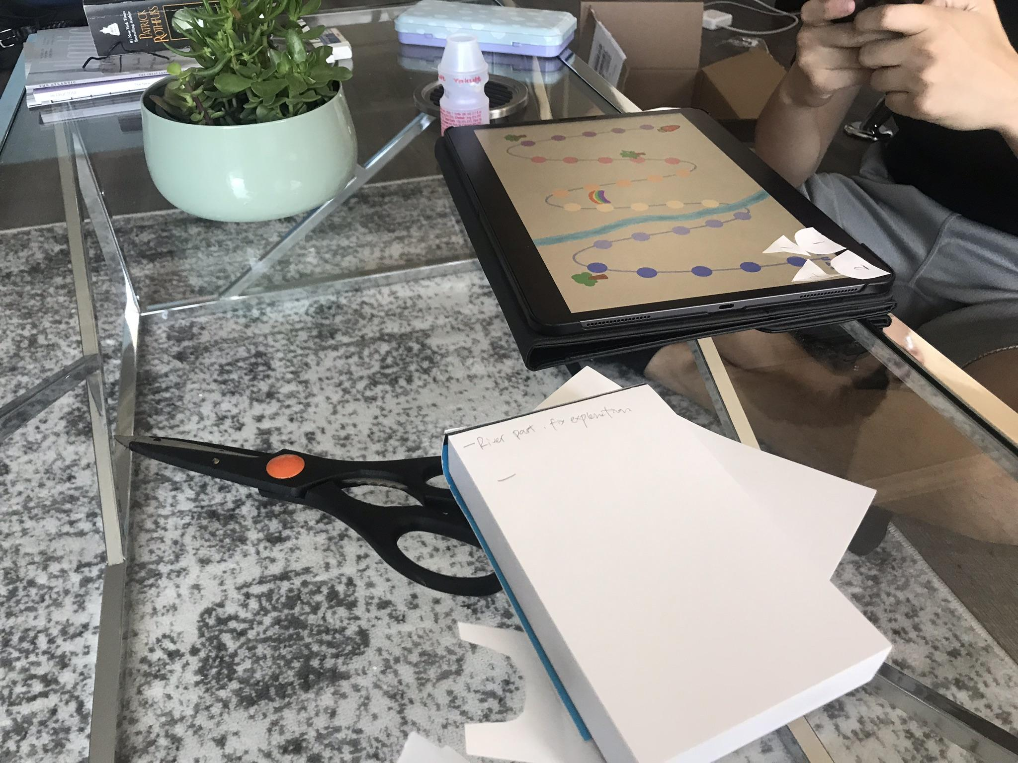

We decided to use the weekend and each do a few play tests with our friends and roommates so that we could get as much feedback as we could from a relatively large group of people. Longkun joined us as a new member and we touched base with him so that he could also start a few play tests. From the feedback we’ve received, we found out a few bigger issues, filled in some logical holes that we weren’t aware of earlier as we designed the initial rules, and also fixed some small bugs in the design of the characters and the map. We’ve also made sure that we timed each play test so that we know if we are doing fine for the playing experience time wisely. We were lucky that most people said that they do enjoy playing the game and they liked the interactions between characters from opponents. The biggest problem we were facing was that most people felt that there could be some more complicated rules to the game so that they could have more fun and be more willing to compete against each other. In order to achieve that and keep the game relatively easy as required for the assignment, we adopted an idea from Longkun’s playtest feedback to add a rule that if the character of the same type lands on each other, the one that arrives previously would be pushed back some steps depending on how many steps the later one took to come to that spot. As we playtested and finalized our game, we also made sure that everything is explained nicely with diagrams in the rulebook so that players can easily understand the game and be able to enjoy it without any troubles. 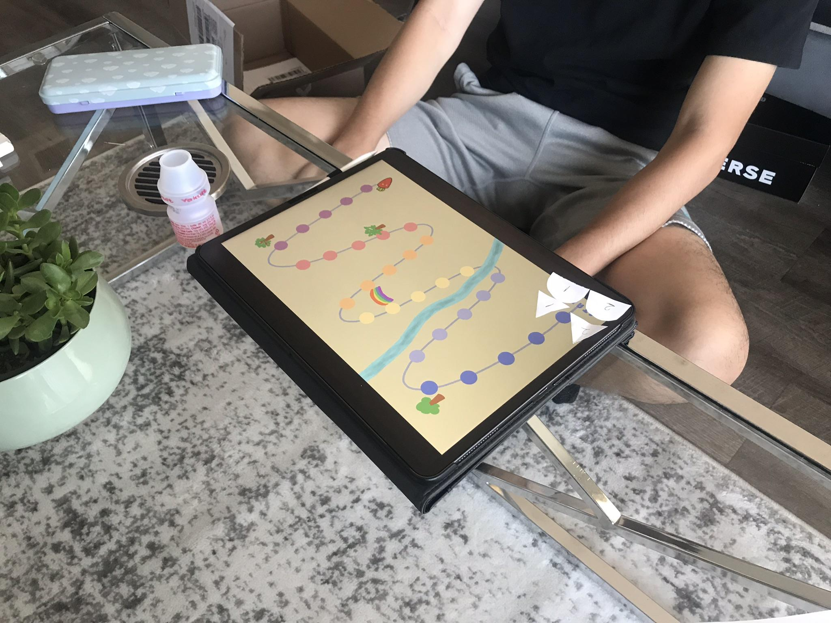

**Attributions:**

Everyone: game design and rules, playtesting and playtest logs

Zichang & Longkun: game rulebook

Venus: design journal

Wushuang: art designs, explanatory diagrams